IFT 166 Introduction to Internet Networking
Lab 11
Spot the difference I

Student Number (last 4 digits only): _6754_____________

Objective
By comparing the configurations in two topologies, find the configuration errors in Topology B.

- In packet tracer, open the file “Spot the difference I” (located in the modules sections below this lab).
You should see the following 2 topologies.

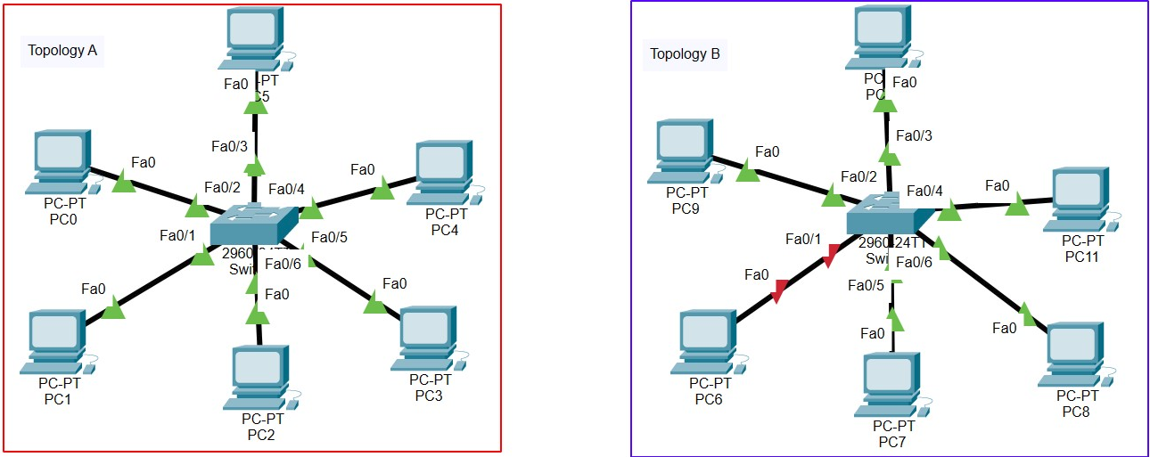

Completed

- All PCs can ping each other in Topology A.
All the PCs in Topology B should be able to ping each other. This is the not the case.
There are 3 configuration differences in the 2 topologies.

Spot the 3 differences.


- List each difference and why/what needs to be corrected to allow the communications.

First Difference: | Wire was connected to wrong port from PC6 to switch 1
What needs to be corrected: | connected to fastethernet



Second Difference: | The port between PC 6 and switch 1 was off
What needs to be corrected: | Turn on port



Third Difference: | describe here
What needs to be corrected: | explain here

